LCD Notes

Liquid Crystal Display

Display(we can display digits and numbers by):

1. LED: too much LED and ports
2. SSD: too much ports

14 seg and 16 seg can not display all numbers

1. LED Matrix 48 led 14 pins

Advantages

1. Easy to control
2. Viewing angle
3. Brightness

Disadvantages

1. Power consuming
2. Two much LED for representation of characters

That’s why there is a need for LCD

A substance like crystal its orientation affected by electric field one side is LED

The other side is screen

Screen is a group of pixels of RGB

Voltage applied to pixels changes the crystal and changing the amount of light of the LED

The crystal is conductor liquid

LCD module has microcontroller itself

Lcd classification

* Color

1. Monochromatic
2. Color LCD

* Function

1. Character LCD saves on it Asci
2. Graphics LCD

Our LCD is Monochromatic character LCD

Our LCD is 16x2

AK for back Light

VDD VSS for power

VD for adjusting contrast and is connected to potentiometer

RS RW E control pins

D0 🡪D7 data pins

LMB161A LCD

RS 0 command is being sent

RS 1 data is being sent

R/w read 1

R/W write 0

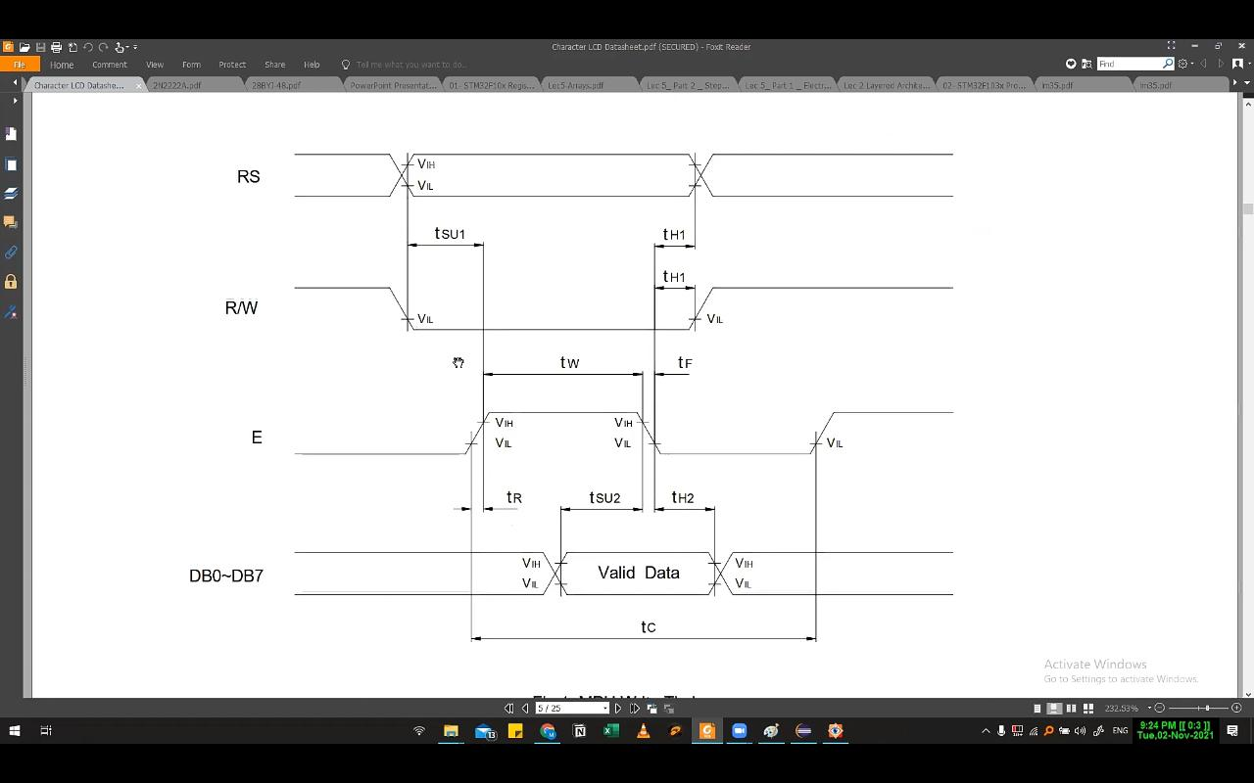Timing Diagram

Timing diagram

commands like clear display and move cursor

data send chars

once command is executed, there is a busy flag ~~that~~ is on

to send data read the busy flag or make delay

make Rw 0 and make delay then make enable

functions of LCD

LCD_SendCommand( u8 command)

{}

first delay tw minimum 230 nsec but let the both delays 1 sec

LCD send char

same but

DIO_SetPinVal (PORTRS,RS,,HIGH)

Rest explanation could extracted from driver \

LCD_vidSendCommand(u8 command){

// Rs -> LOW

DIO_vidSetPinVal(PORTD,RS,LOW);

// R/W low to write on LCD

DIO_vidSetPinVal(PORTD,RW,LOW);

DIO_vidSetPortVal(PORTC,u8 value);

DIO_ vidSetPinVal(PORTD,E,HIGH);

delay_ms(1);

DIO_ vidSetPinVal(PORTD,E,HIGH);

delay_ms(1);

DIO_ vidSetPinVal(PORTD,E,LOW);

delay_ms(1);

}

LCD_vidSendChar(u8 command){

// Rs -> High

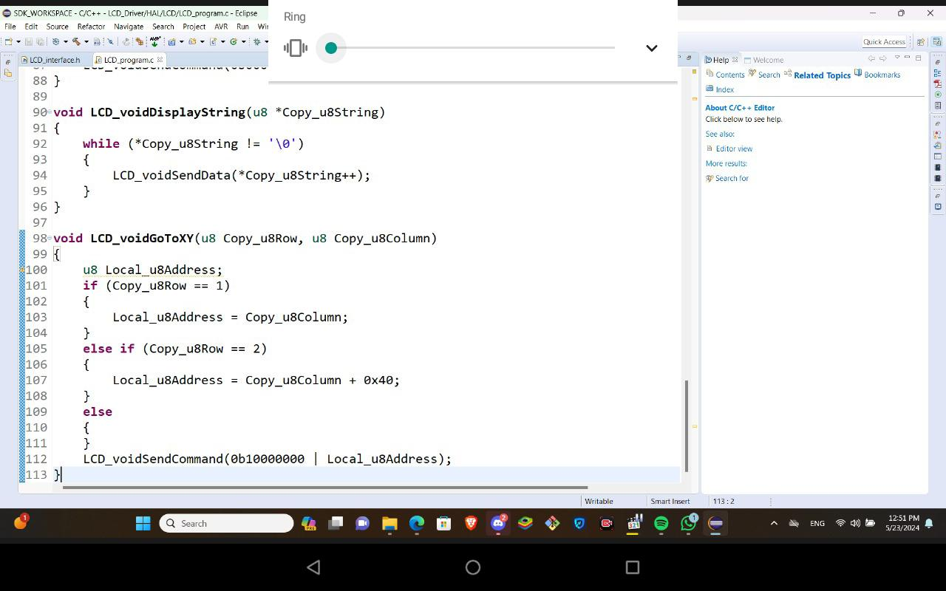DIO_vidSetPinVal(PORTD,RS,LOW);

// R/W low to write on LCD

DIO_vidSetPinVal(PORTD,RW,LOW);

DIO_vidSetPortVal(PORTC,u8 value);

DIO_ vidSetPinVal(PORTD,E,HIGH);

delay_ms(1);

DIO_ vidSetPinVal(PORTD,E,HIGH);

delay_ms(1);

DIO_ vidSetPinVal(PORTD,E,LOW);

delay_ms(1);

}

Void LCD_vidInit(void){

//View driver

DIO_SetPortDirection(PORTD,OUTPUT);

DIO_SetPortDirection(PORTC,OUTPUT);

}

In initialization we use the vid_SendCommand(u8 comand) since RS and RW are equal zero

From data sheet

N=1 two line display

N=0 one line display

F = set to zero to let it 5x7

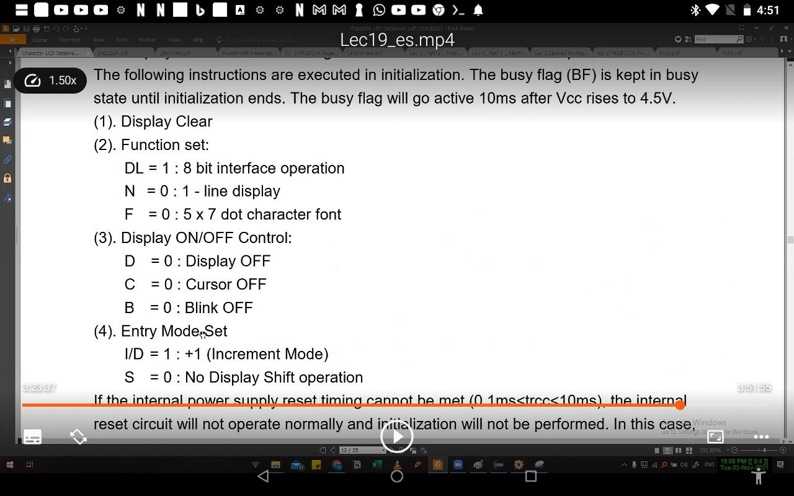

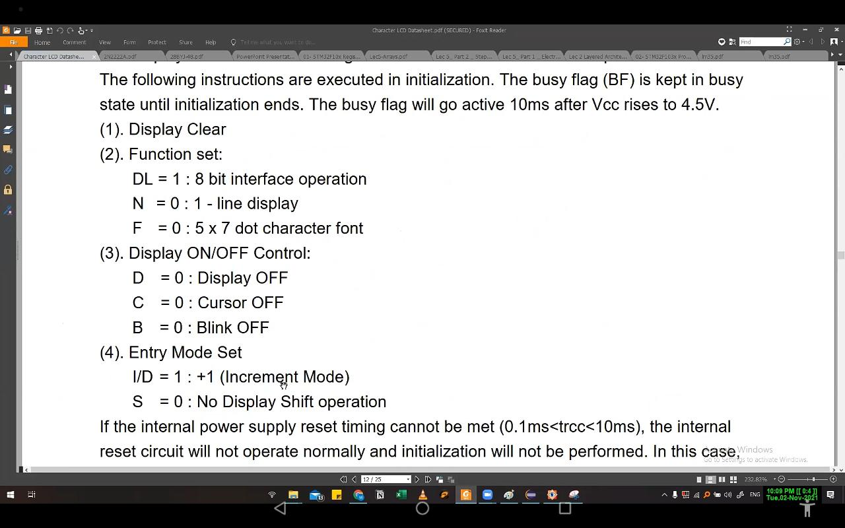

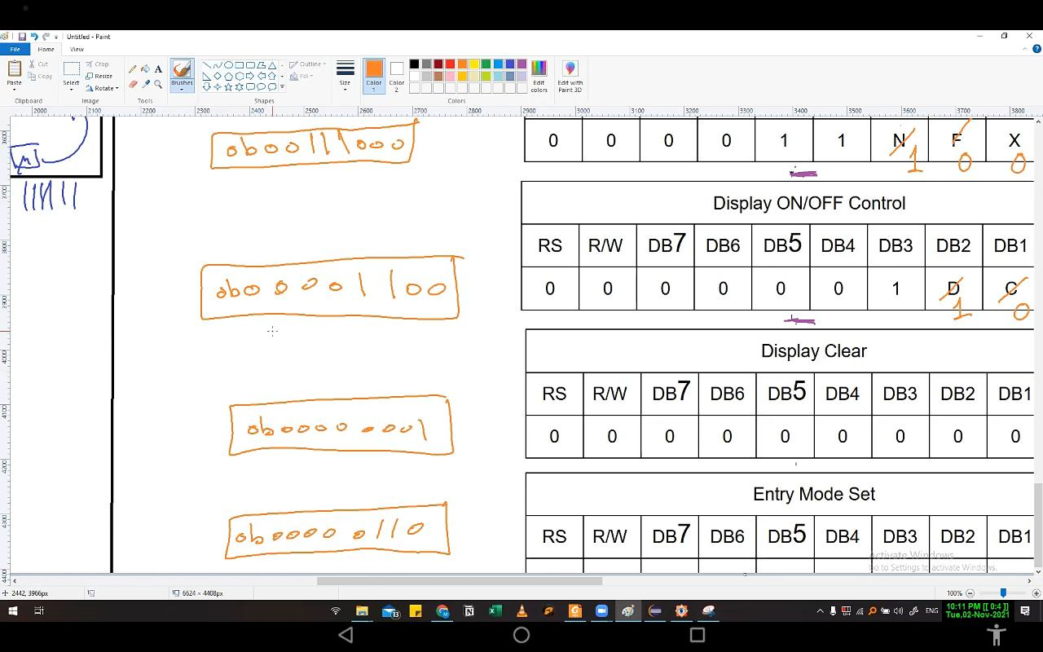

View driver for delays in initialization